Angular 2

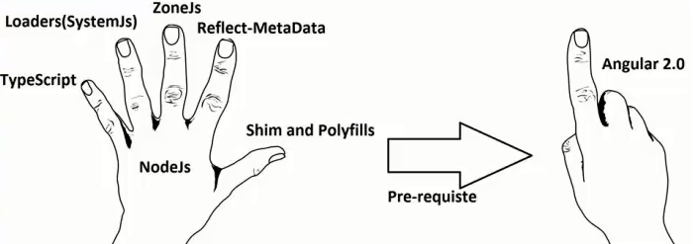

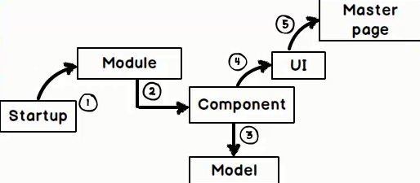

Loading Mechanism;

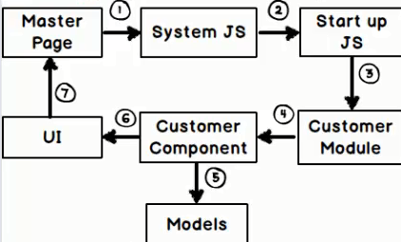

1-way/2-way binding, interpolations, template binding, event binding & cloning.

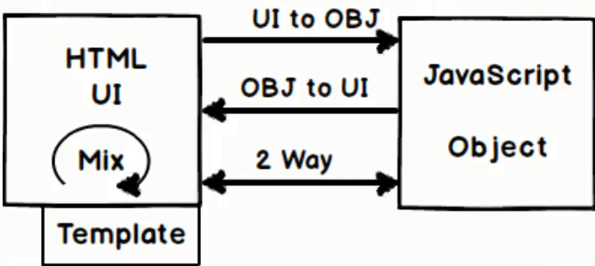

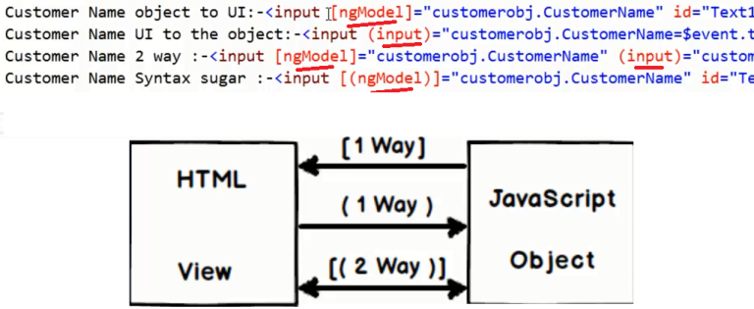

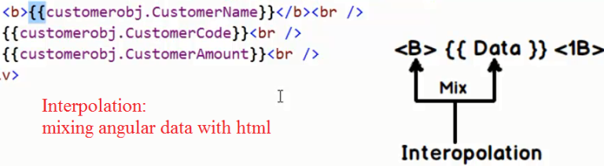

Add Submit Button Event;

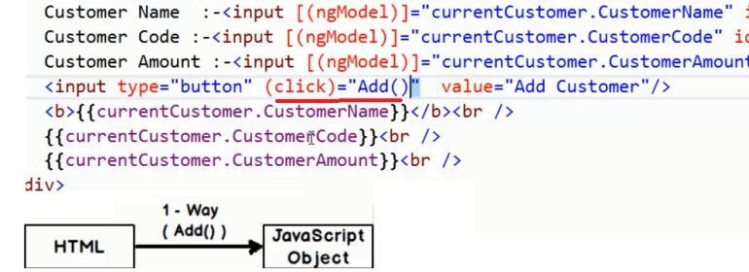

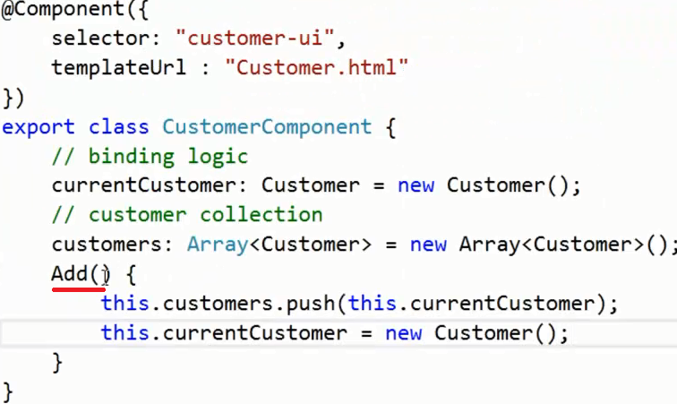

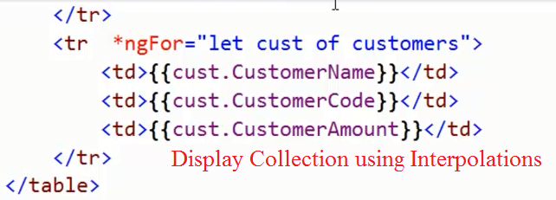

Exe: do simple in-memory CRUD. ☺

@Input, @Output & Event Emitters.

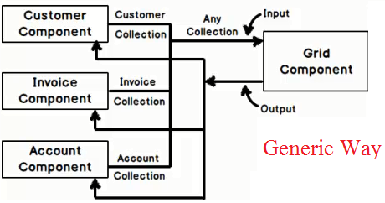

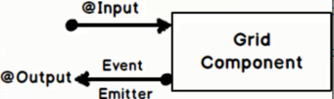

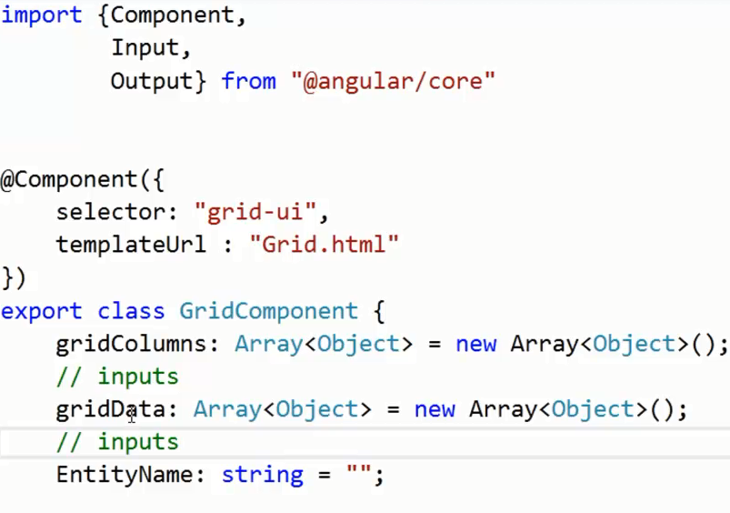

@input use [ ]

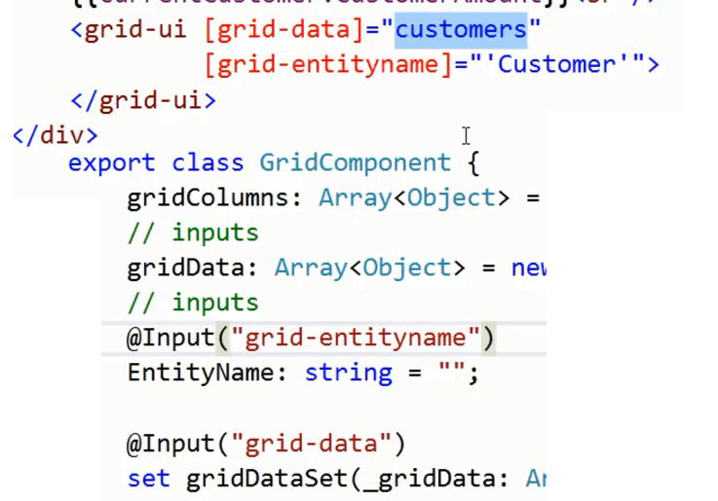

Angular Change Detection Mechanism

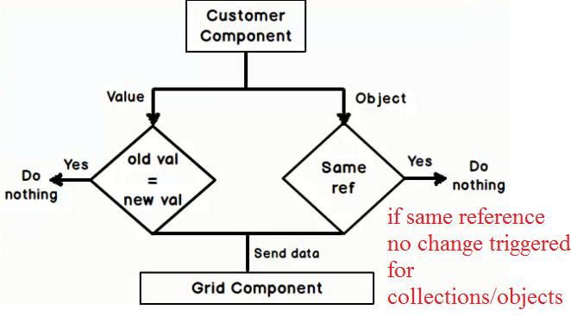

For detecting changes with the objects, you have to change the reference of it.

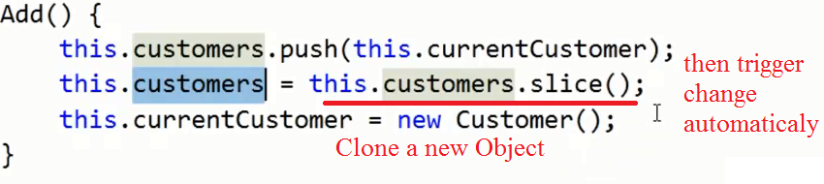

What is Slice() in Arrays?

@Output ( )

Event-Emitters used to Emit out values to the parent component.

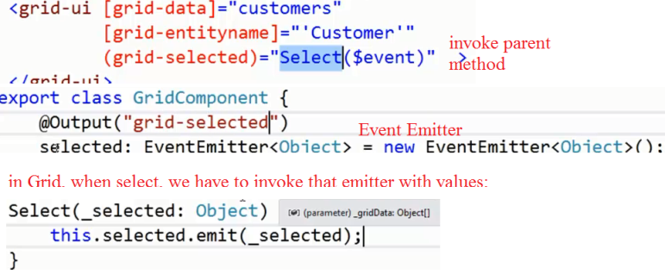

Angular Component Life Cycle

Component is the Binder, Controller.

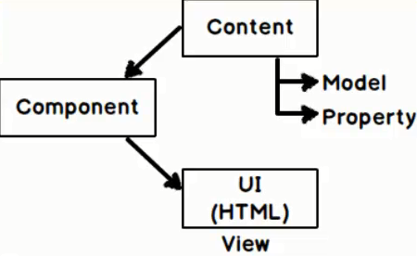

Life Cycle – 2 DOM

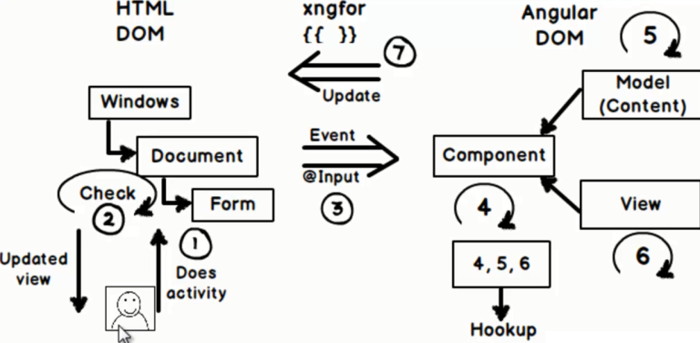

Hookup Points (9 Events);

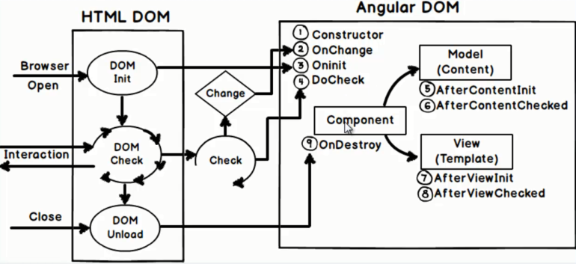

The “Check Event” fires literally everything, but you want to listen activities where your data changes.

Event - “OnChange()” used.

To force the use of ngOnInit(), use its interface;



Providers, Services and Dependency Injection.

Use a Factory Pattern;

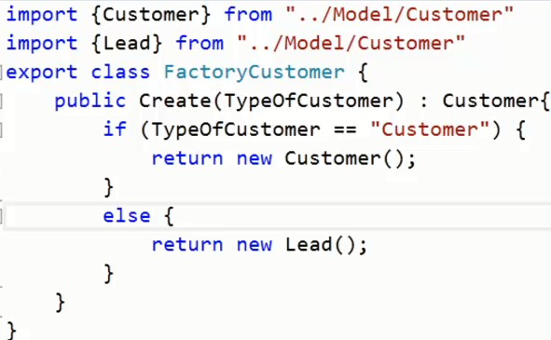

Normal way;

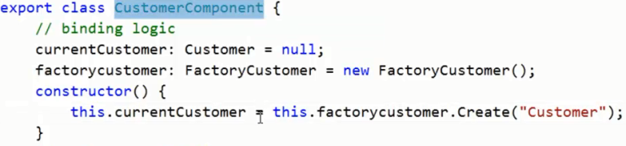

Fully Decoupled way using DI; (Providers) ,@Injectable()

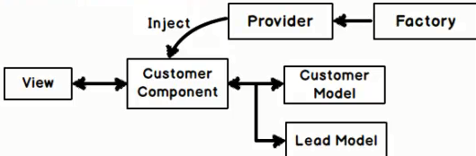

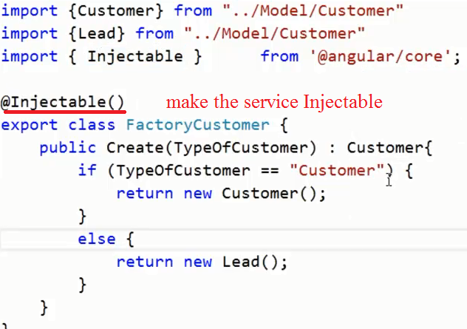

In where we use them, have to define as the[Providers]

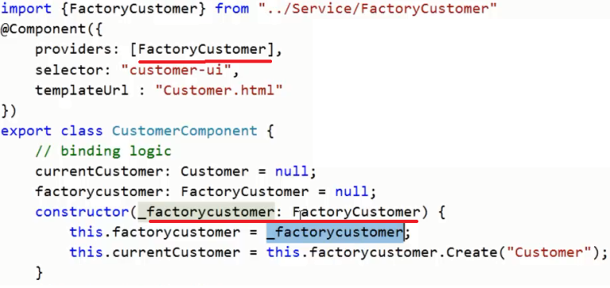

Injection Providers can be done in Component level or Module Level.

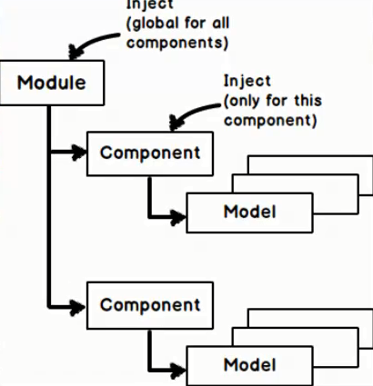

Exe: Bind selection-box and create dynamic models from factory;

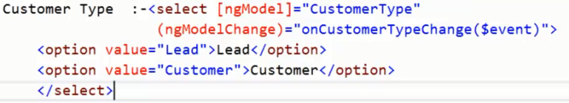

Sample Folder Structure: with service Folder

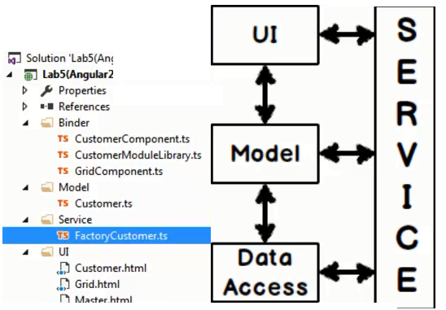

SPA (Single Page Application) using Routing

Normal Structure of a SPA;

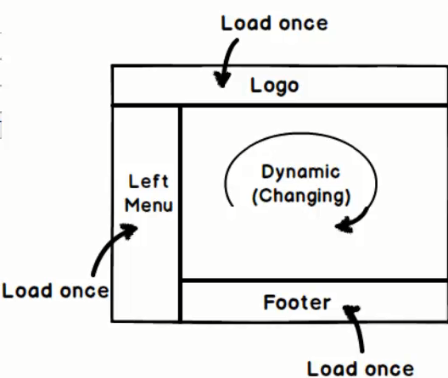

Add a Master Page and define the Layout;

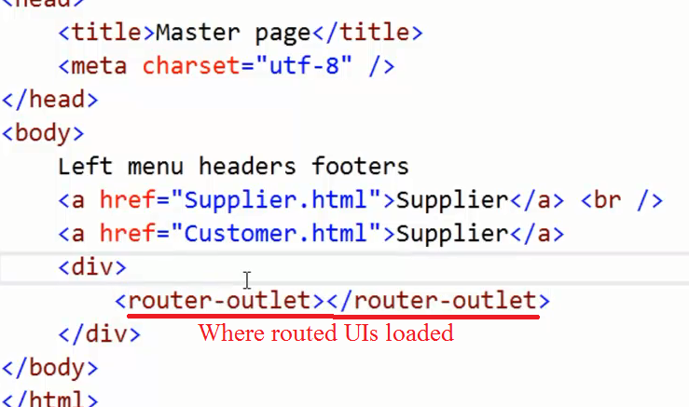

Sample navigation;

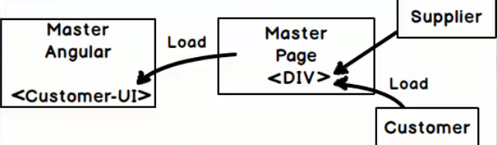

We should define “Routing.ts”

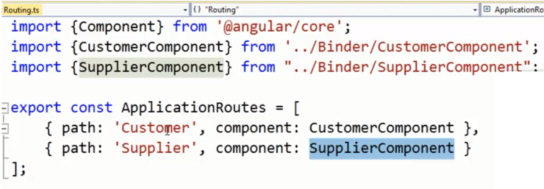

Then we have to change the navigation;

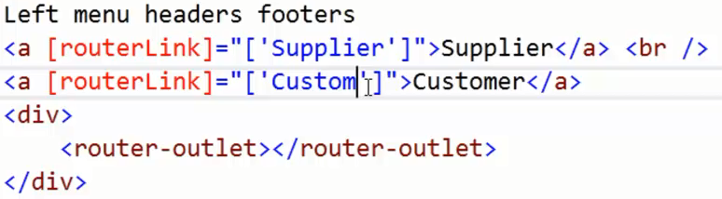

Import routings in your main Module;

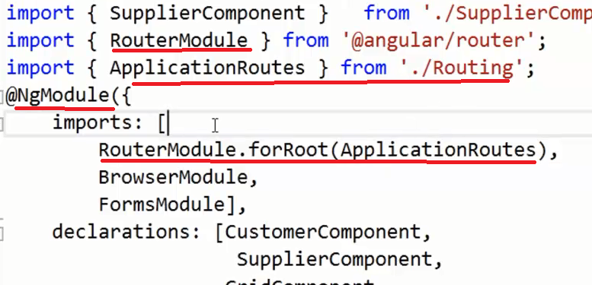

If you want you can define a base url pattern;



Summary;

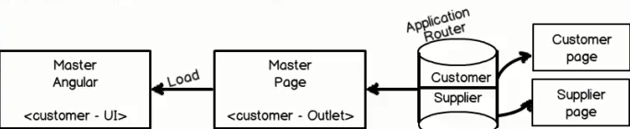

Validation using Angular forms.

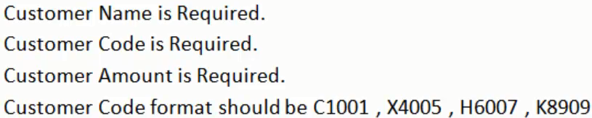

Where we put validations;

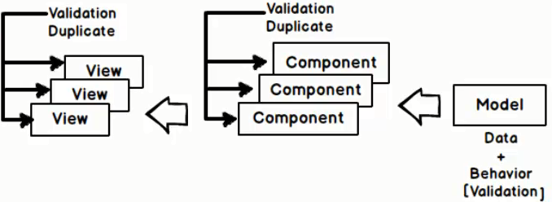

Validations are for data and its behaviors, so its logical to put validation inside “Model”.

Import all ng Form Validators to the Model;

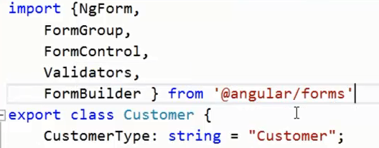

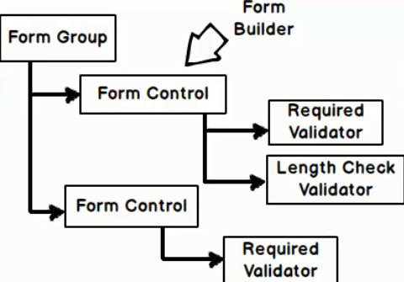

Sample: All fields are required and customerCode needs a pattern match.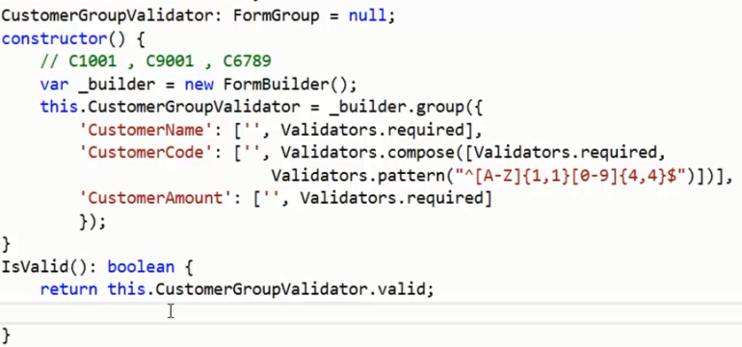

Import validations to the main module;

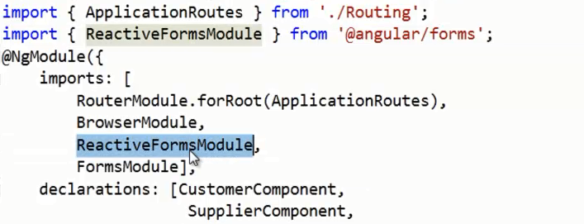

Note: to perform Form Validations, your code block should be inside <form/> tag; and associate “formGroup” valiable here;

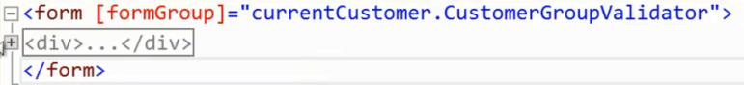

Then bind validators with the html inputs;

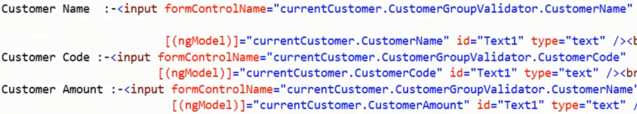

Note: By default, all the controls inside <form [formGroup]> try to validate itself. So want to exclude from validation;

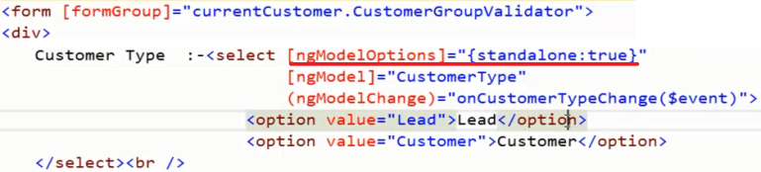

Have to bind each error to the UI,

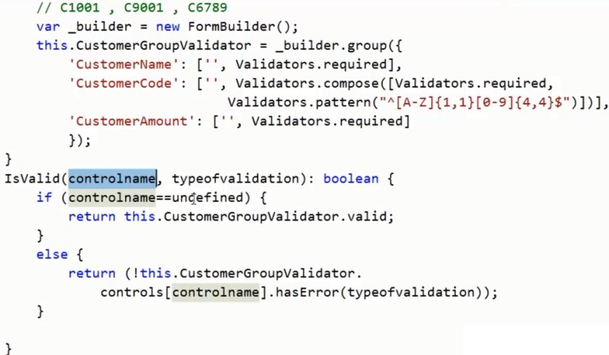

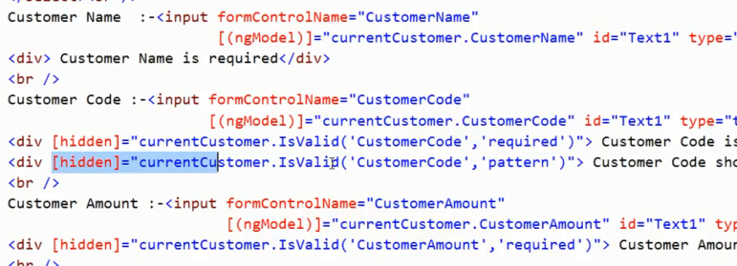

Have the value change or not: check “Dirty”

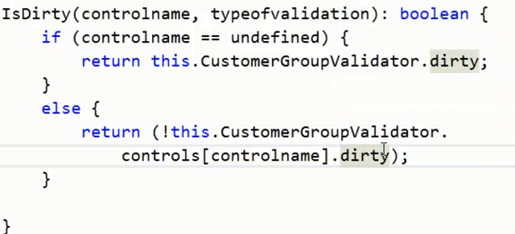



Some useful Form STATES;

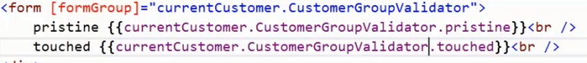

{ IsDirty, IsValid, Pristine, Touched }

Making HTTP POST calls to REST service (WebAPI) using Angular 2.

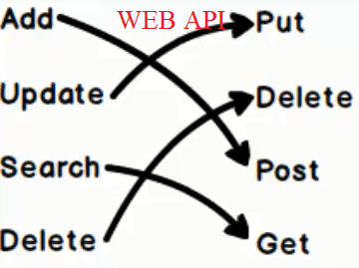

Enabling Cross Domain Access in Web API; (2 things)

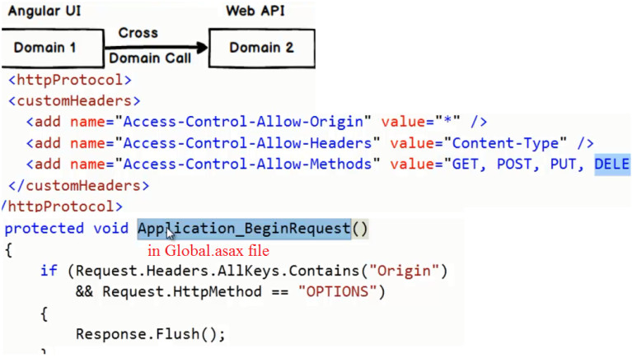

Don’t return general collections, use proper http responces;

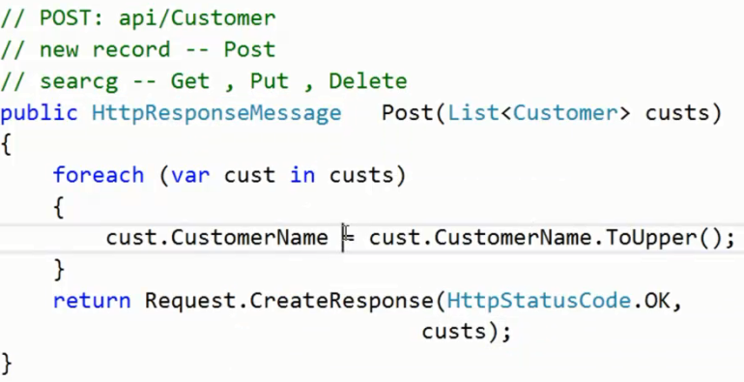

In Ng;

In the Main Module;



In Each Component;

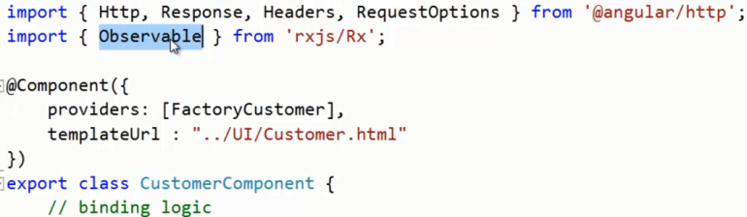

In constructor, inject http service;

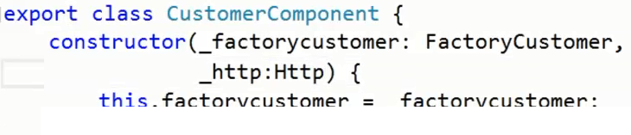

POST sample;

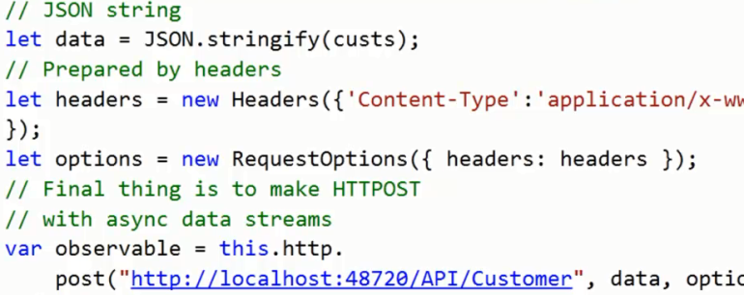

Use of RxJs;

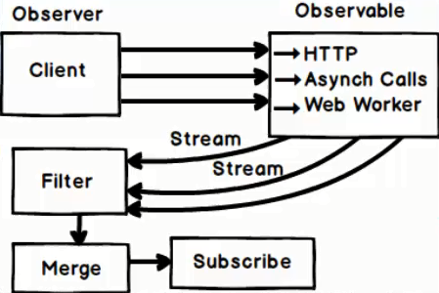

Manage Async events through RxJs;

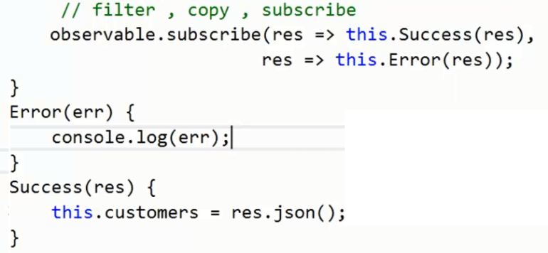

@Pipes()

Pipes used to be called filters in Angular 1.x. They're used for transforming data within your views, and can be used in any template expression.

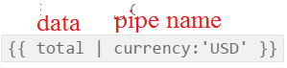

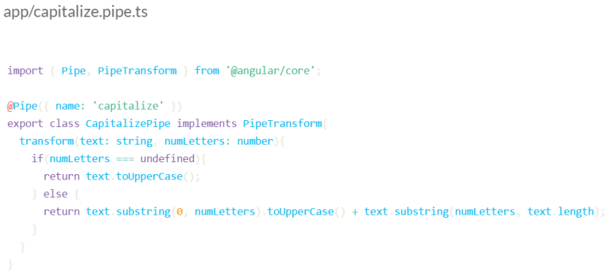

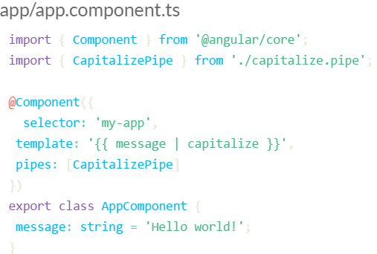

Angular 2 Directives

The three types of directives in Angular 2 are attribute directives, structural directives, and components.

Components are directives that have a template.

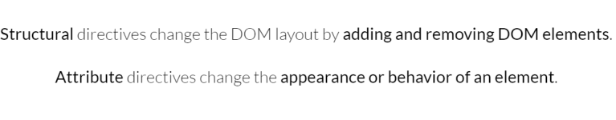

Structural directives;

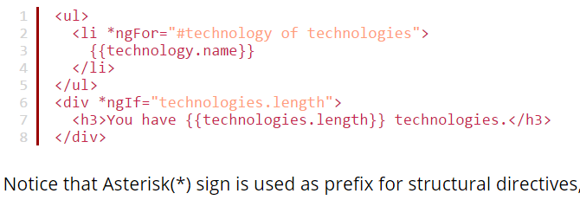

Lazy loading using Angular 2

Organize in to Modules.

Lazy Loading in Main Routing. Use loadChildren

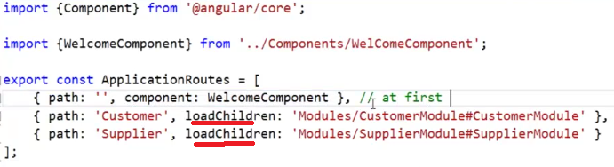

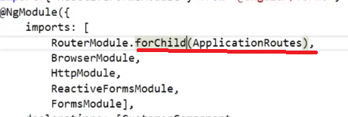

Web Pack in Ng2

* Reducing http requests – Bundle them
* Minimize download data – Compress

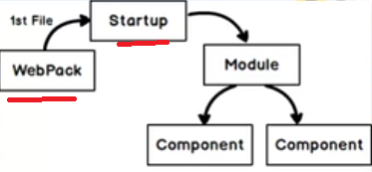

Add a webpack.config.json file

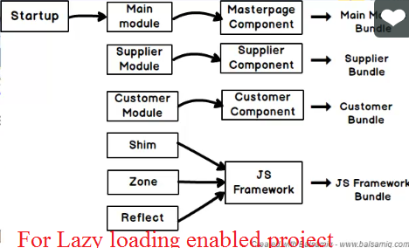

Angular 2 vs. Angular 1: Key Differences

* Ng2 -> Component-based development and object orientation are much easier.
* $scopes and controllers are canceled completely.
* Written entirely in Typescript and meets the ECMAScript 6 specifications.

##### Curly braces now denote a **one-way binding.**

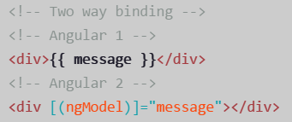

Goodbye ng-app, hello Bootstrap

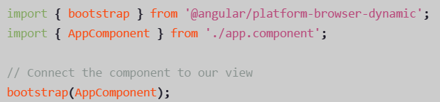

Controllers no longer exist

Instead we use Components to manage our views.